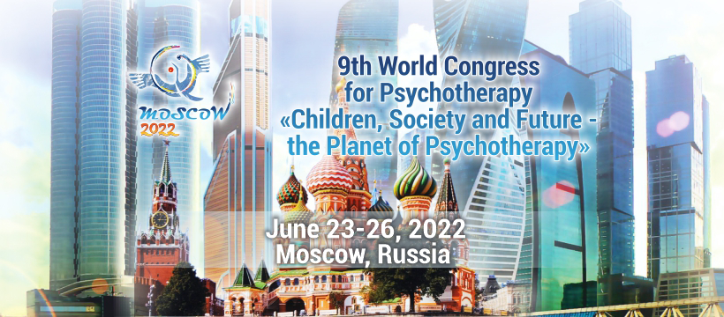

Dear colleagues!

We kindly invite you to become a part of the IX World Congress for Psychotherapy «The Planet of Psychotherapy», held on June 23-26, 2022 IN HYBRID: both in Moscow, Russia and Online – four days of intense fully paralleled program. Pre- and post-congress events will take in most scenic regions of Russia: Altai Mountains and Lake Baikal.

The World Congress of 2022 will be held in the Russian Federation according to the decision of the World Council for Psychotherapy, which kindly entrusted the organization of the largest professional event in the world to the Professional Psychotherapeutic League of Russia and its partners.

In past decades psychotherapy has become a worldwide phenomenon; and we expect to welcome guests from more than one hundred countries, from all continents, from all over the world at the Congress.

The Congress expects to welcome more than 2000 esteemed professionals. Many colleagues have already confirmed their attendance. The Congress will feature real-time video conferencing with most notorious psychotherapists of the Globe.

DEADLINE FOR SUBMISSIONS IS NOW OPEN.

OUR WORLD-FAMOUS SPEAKERS:

Alfred PRITZ (Austria)
Victor MAKAROV (Russia)
Alfried LAENGLE (Austria)
Emmy VAN DEURZEN (UK)
Nicole AKNIN (France)
and many others!

The IX World Congress for Psychotherapy is organized as a festival of psychotherapy — PSYFEST. It brings together professional, both scientific and practical, educational and social features of our profession.

To learn more about the IX World Congress for Psychotherapy, please visit http://en.planetofpsychotherapy.com/ and https://psyplanet2022.com/

We would be pleased with your attendance and possible cooperation, including media partnership or any other forms of mutual contribution.

Should you have any questions and/or inquiries, please do not hesitate to contact us via oppl.doc@gmail.com and WCPcongress@oppl.ru.
We look forward to hear from you and are ready to provide you any additional information you might require.

With best regards,

On behalf if the Executive team of the IX World Congress for Psychotherapy,

Sofiya Kamalova,
Representative for the Organizing Committee,
International Affairs Officer,
Scientific Program Coordinator
IX World Congress for Psychotherapy 2022
oppl.doc@gmail.com
WCPcongress@oppl.ru
+7 916 062 00 26, +31 6 87 08 19 64

